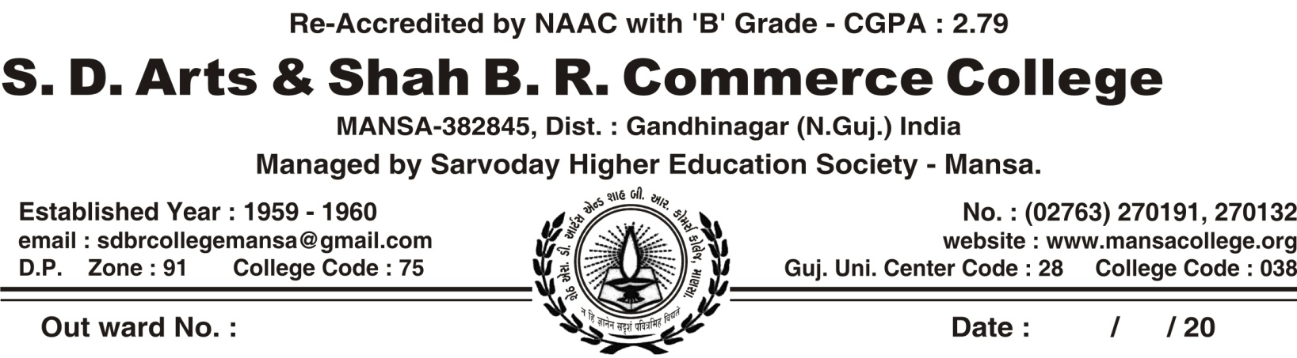

REGULAR ACTIVITY OF CWDC COMMITTEE, MANSA COLLEGE (2019-20)

SR.NO | DATE | NAME OF ACTIVITY | NUMBER OF PARTICIPANTS | COLLABORATION WITH
 | 20/7/2019 | Orientation lecture on  Topic: Legality of Women Rights | 156 | Speaker : Shri Sudhirbhai Desai, By CWDC Committee Of Mansa College itself
 | 23/7/2019 | Organized Mahedi Competition | 7 | By CWDC Committee Of Mansa College itself
 | 23/7/2019 | Organized Cooking competition | 5 | By CWDC Committee Of Mansa College itself
 | 24/7/2019 | Organized Hair style competition | 3 | By CWDC Committee Of Mansa College itself
 | 24/7/2019 | Organized Rangoli competition | 13 | By CWDC Committee Of Mansa College itself
 | 7/8/2019 | Lecture on Problems of Female Health | 141 | Speaker : Dr. Aditisingh  ( Gynecologist)
 | 8/8/2019 to 10/8/2019 | Organized Handicraft workshop  Subjects: Glass Painting & Flower Making | 15 | Trainer: Jayeshbhai Khorasiya
 | 27/8/2019 | Film show “Beti” | 70 | By CWDC Committee Of Mansa College itself
 | 3/1/2020 | Organized Inter College Competition  Subjects :(1) Poster Making (2) Story Writing  (3) Poetry Writing – on  Female Subject  (4) Essay Writing | 60 | By CWDC Committee Of Mansa College itself
 | 17/1/2020 | demonstration on Project Making | 5 | CM Patel Nursing College, Gandhinagar
 | 9/3/2020 | Celebration of “World Women’s Day” | 7 | Speaker: Prajapati Manjulaben K.  ( Trader of Potato)
 | 3-1- 2020. | Prize distribution inter college competition | 5 | By CWDC Committee Of Mansa College itself

Orientation Lecture On
Topic: Legality Of Women Rights Topic: Legality Of Women Rights 20/7/2019 Speaker: Shri Sudhirbhai Desai
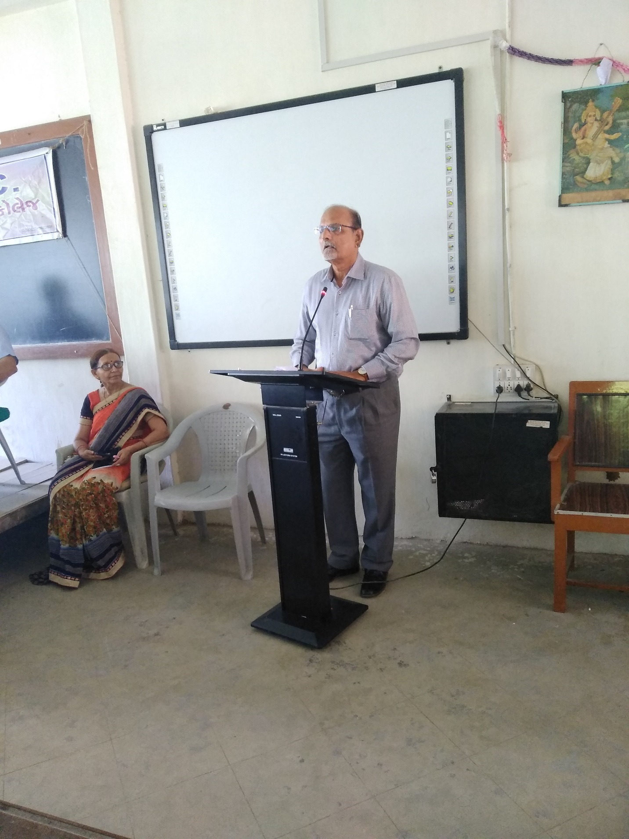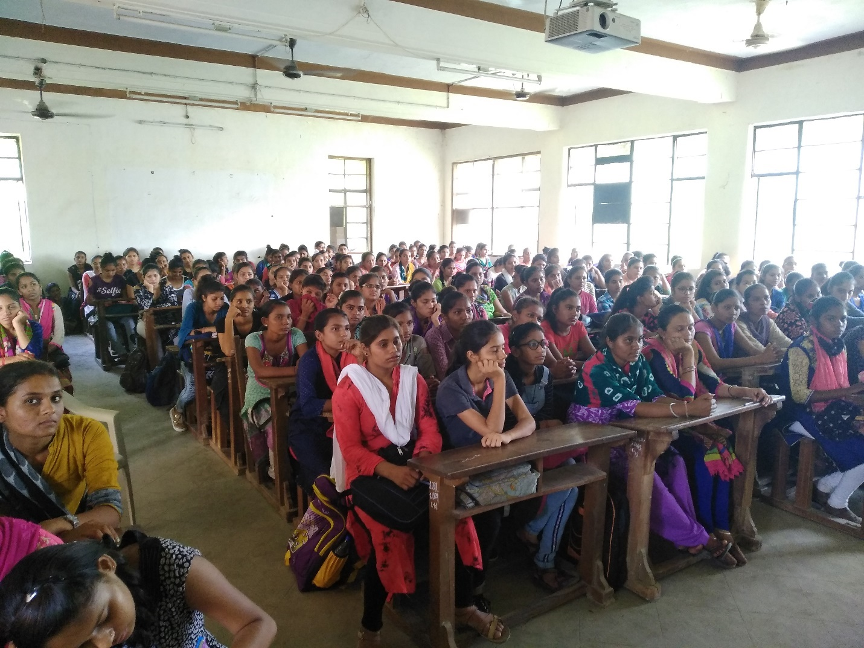
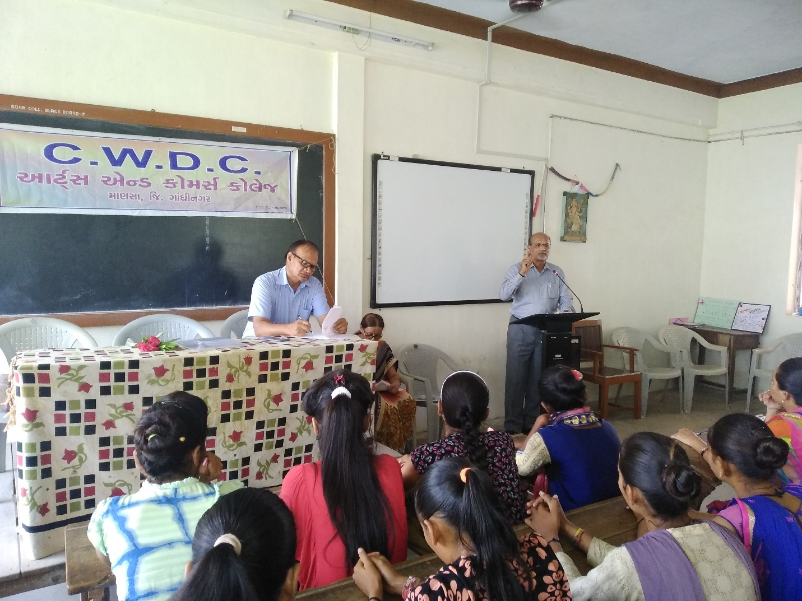
Organized Mahedi Competition 23/7/2019
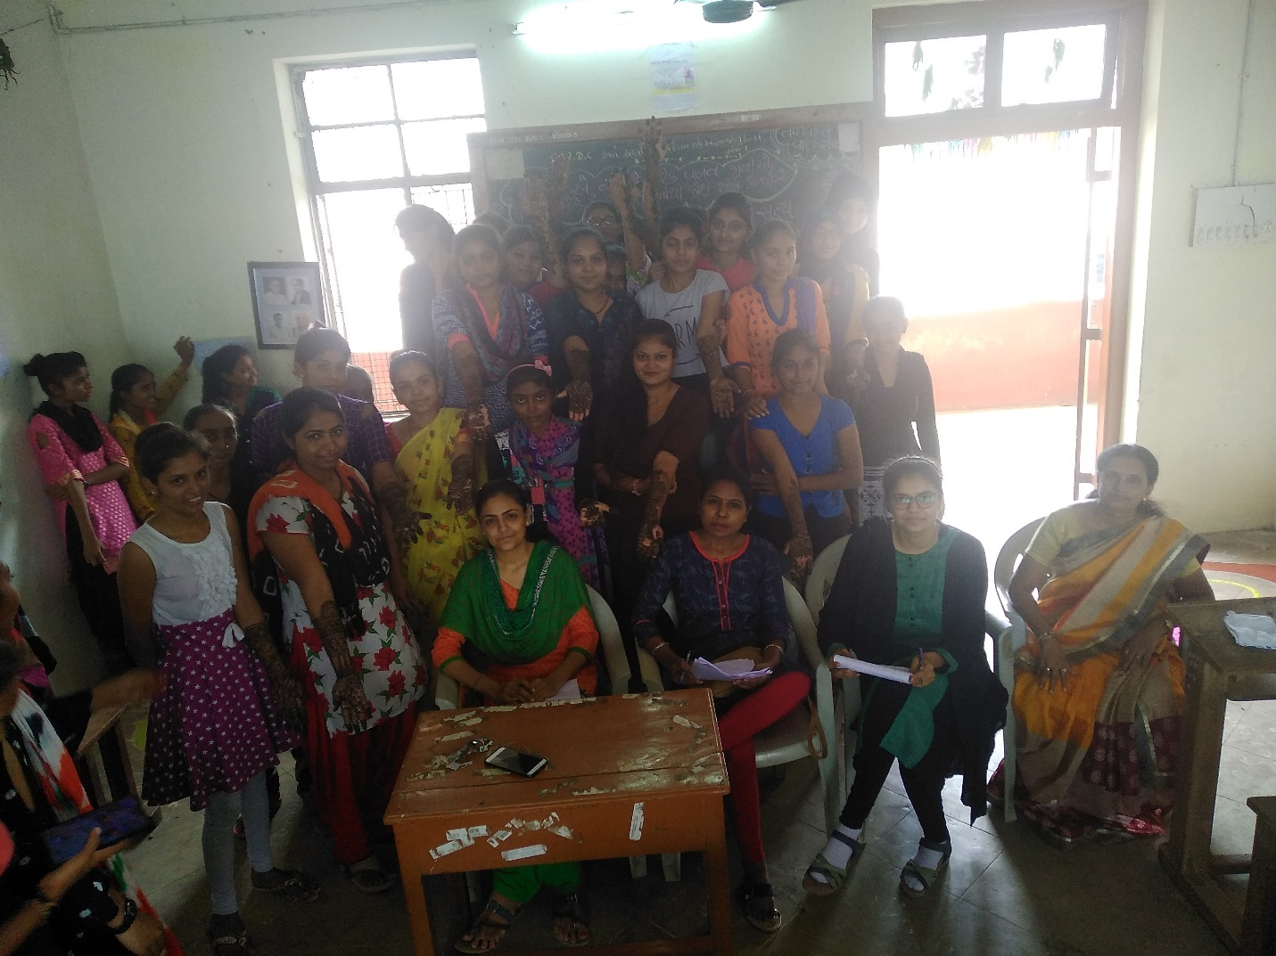
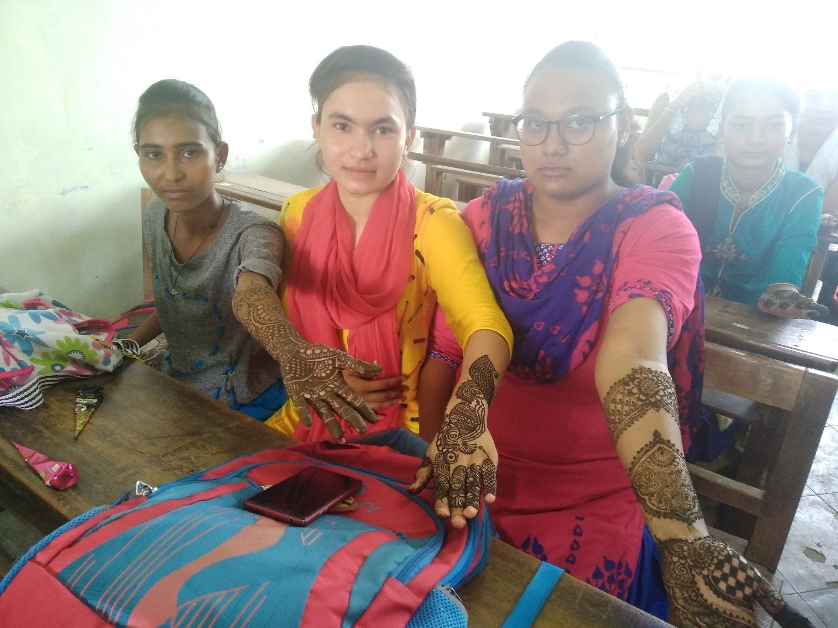

Organized Cooking competition 23/7/2019
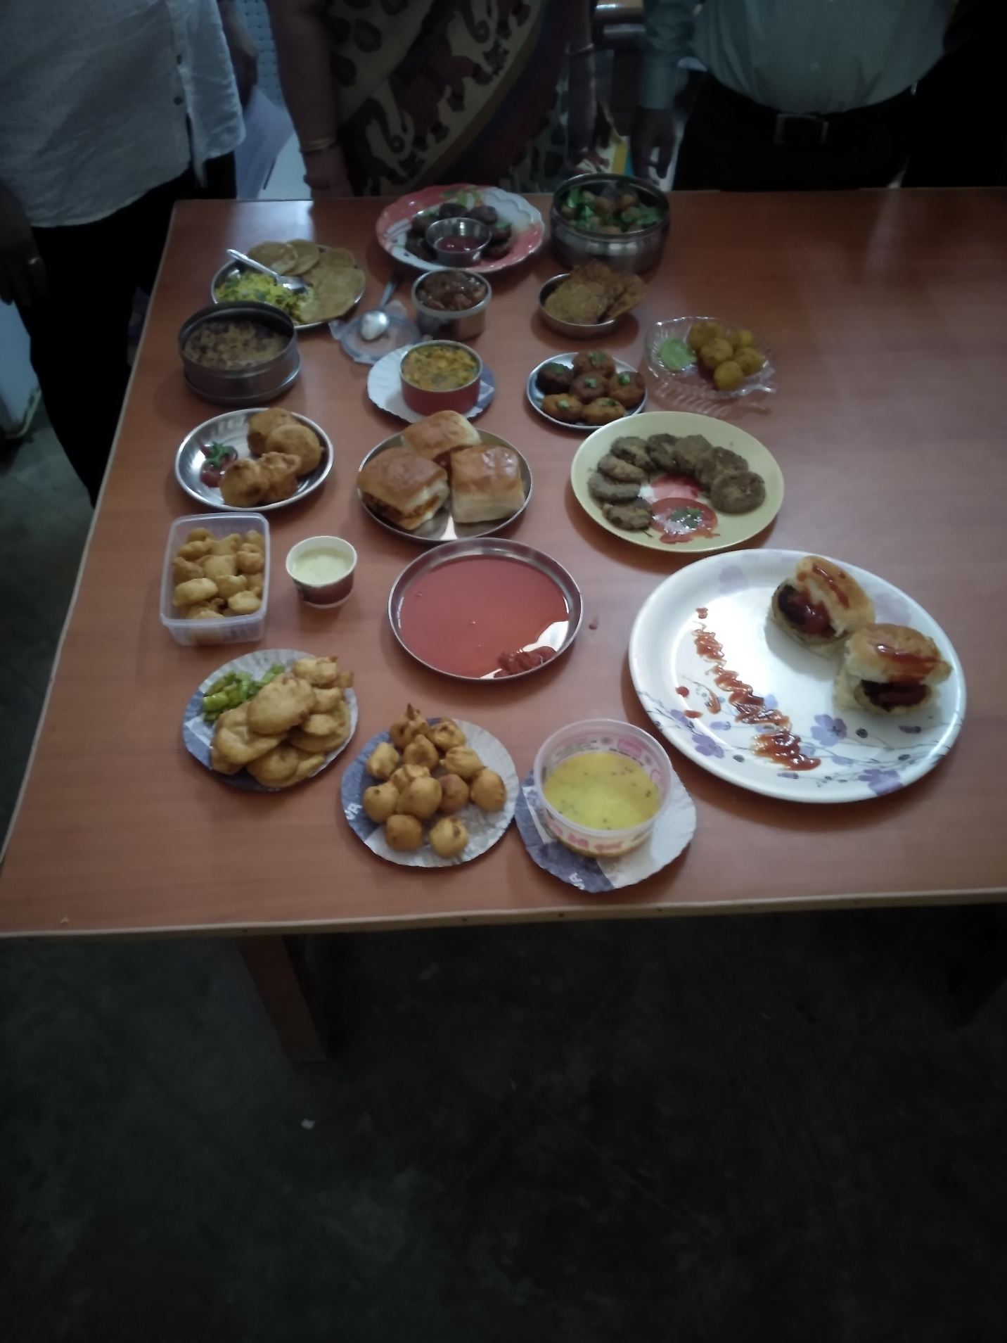
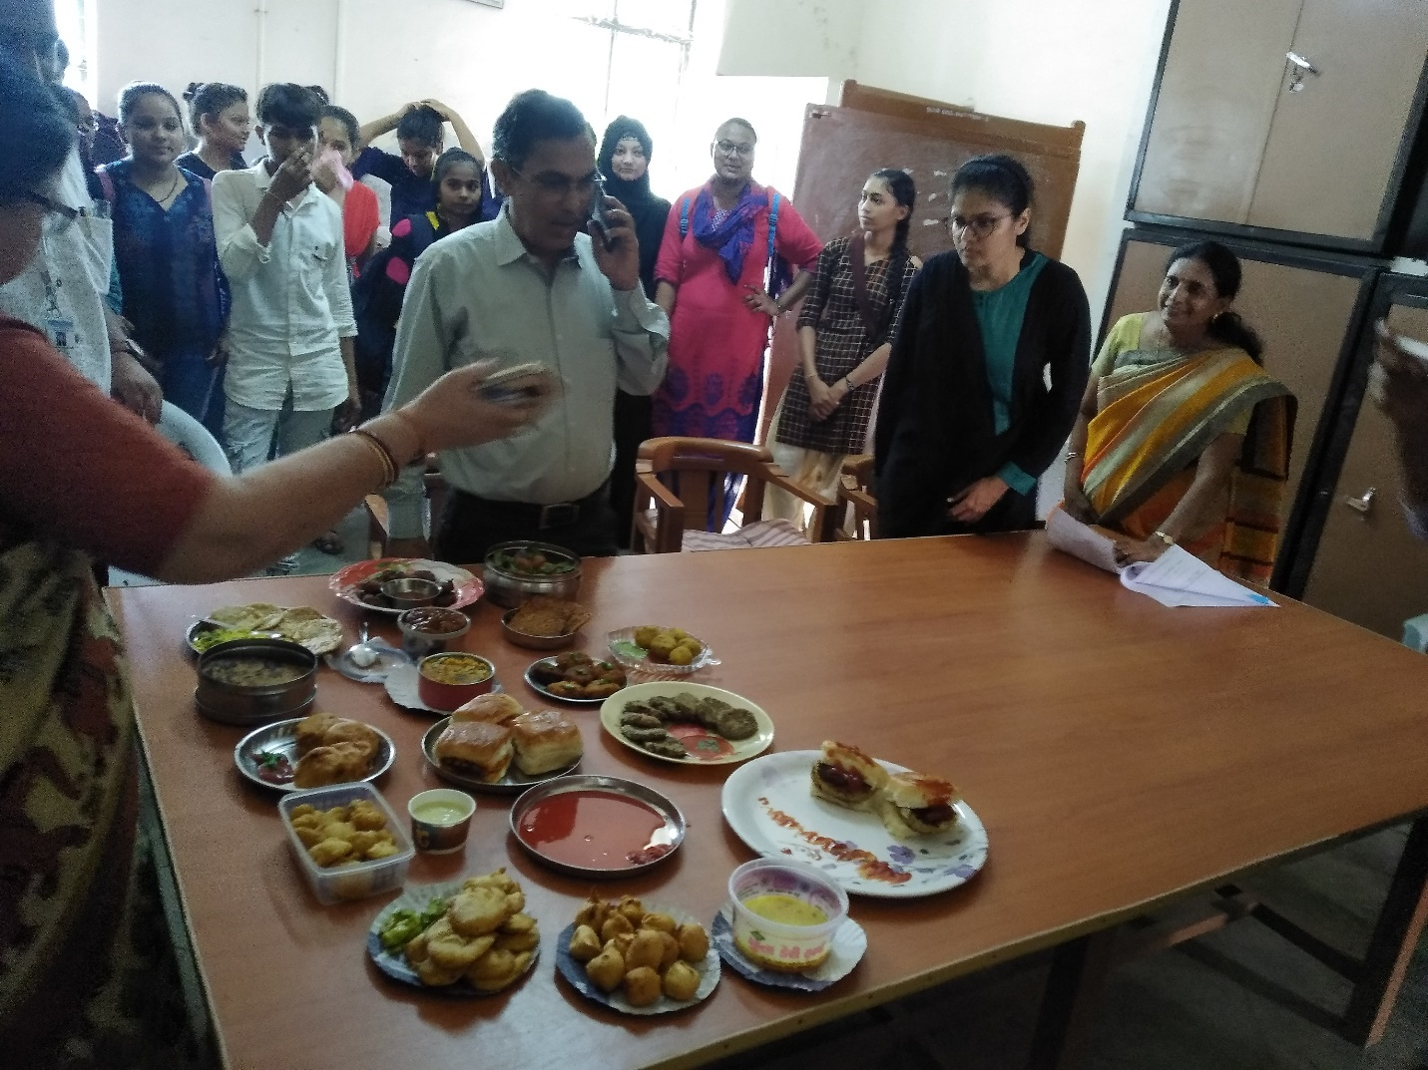
Organized Hair style competition 24/7/2019
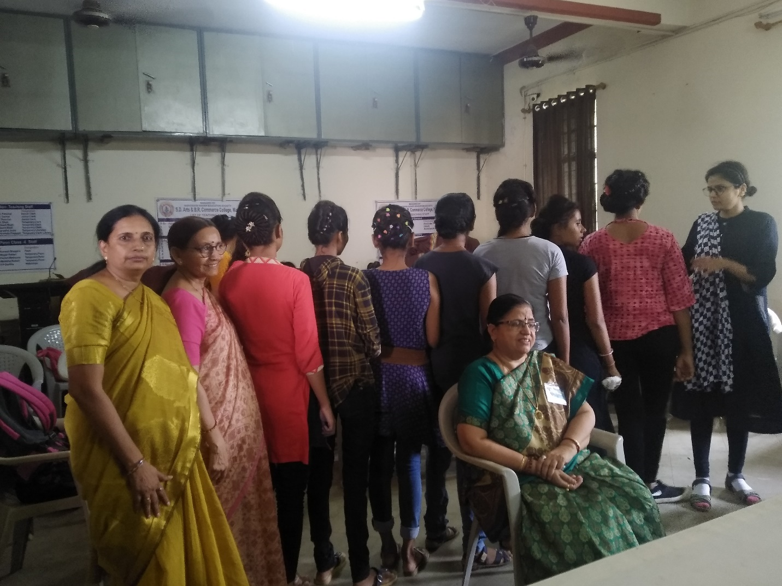
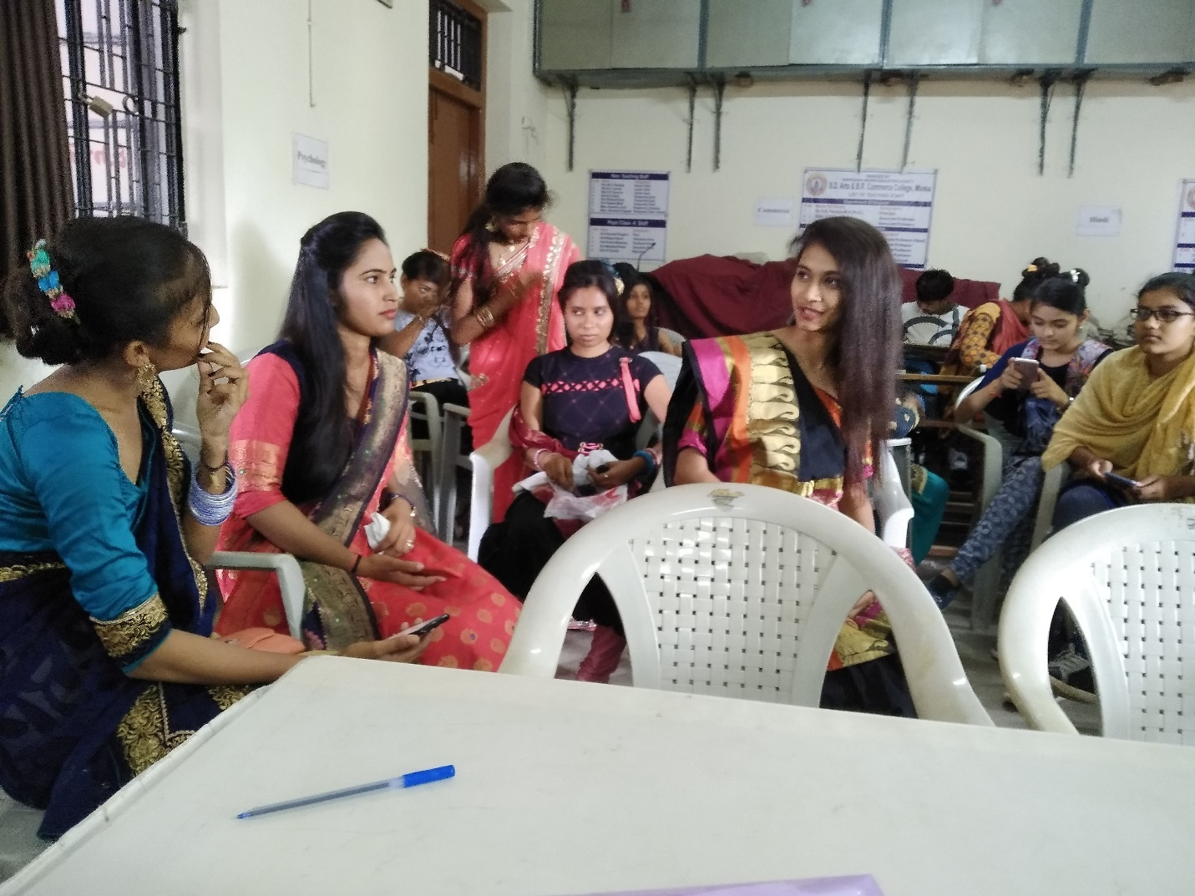
Organized Rangoli competition 24/7/2019
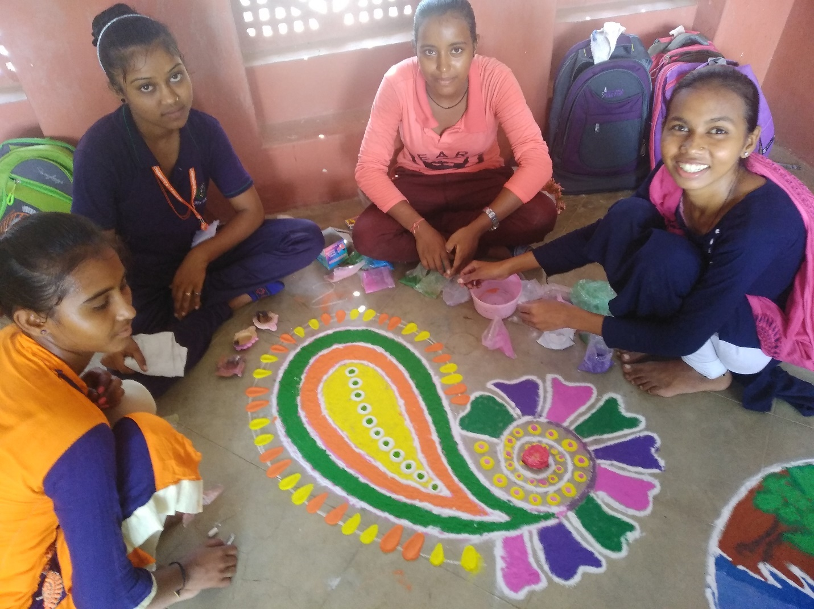
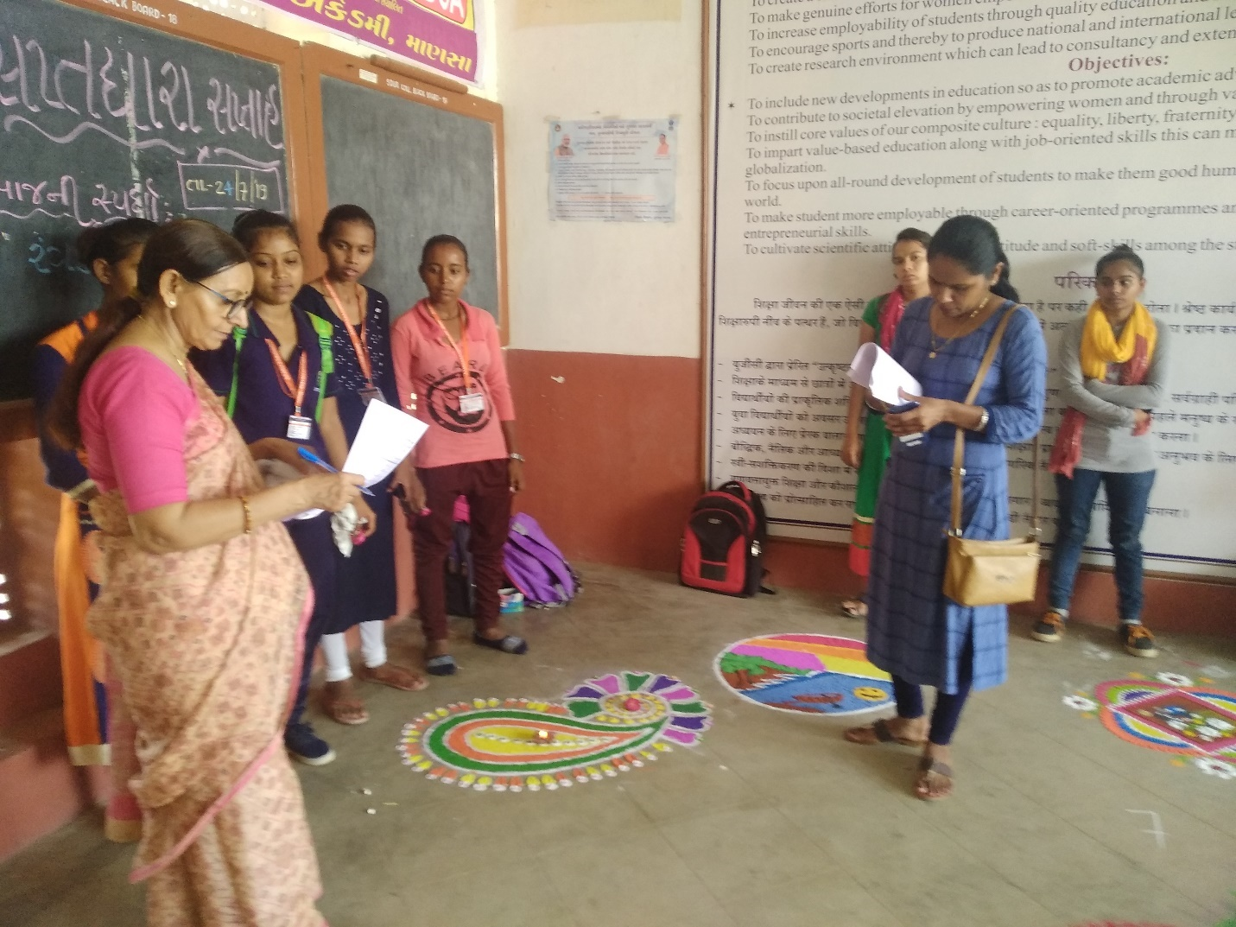
Lecture on Problems of Female Health 7/8/2019
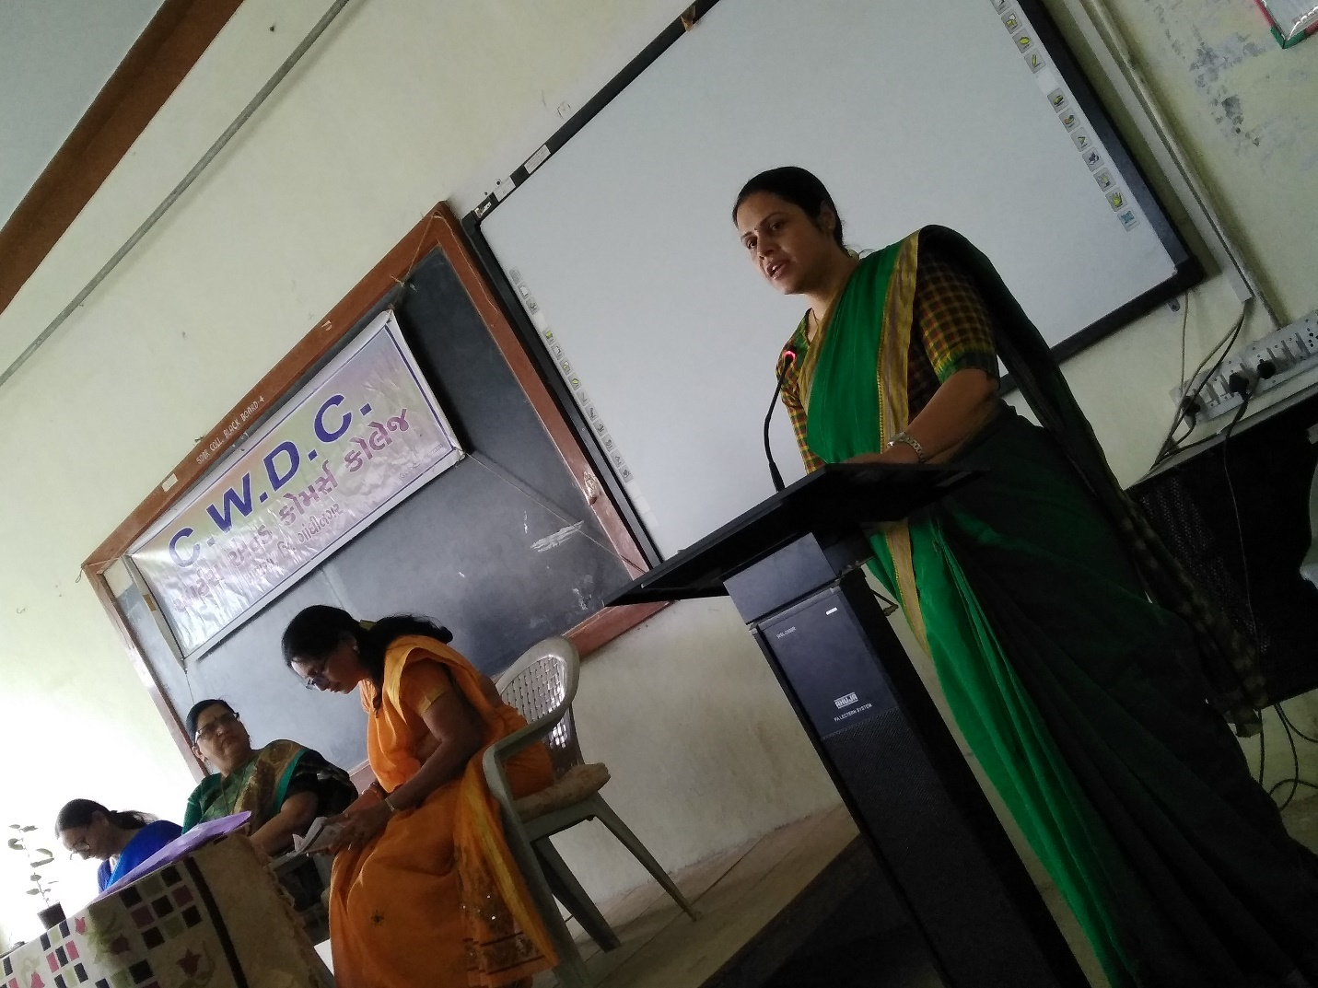
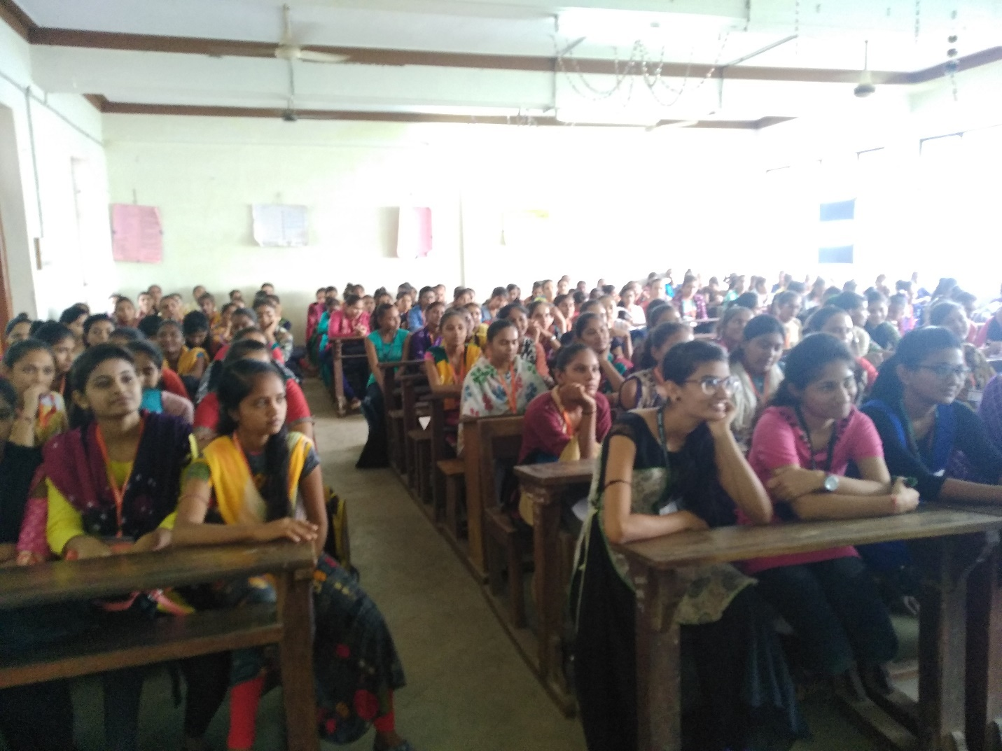

Organized Handicraft workshop 8/8/2019-10/8/2019
Subjects: Glass Painting & Flower Making
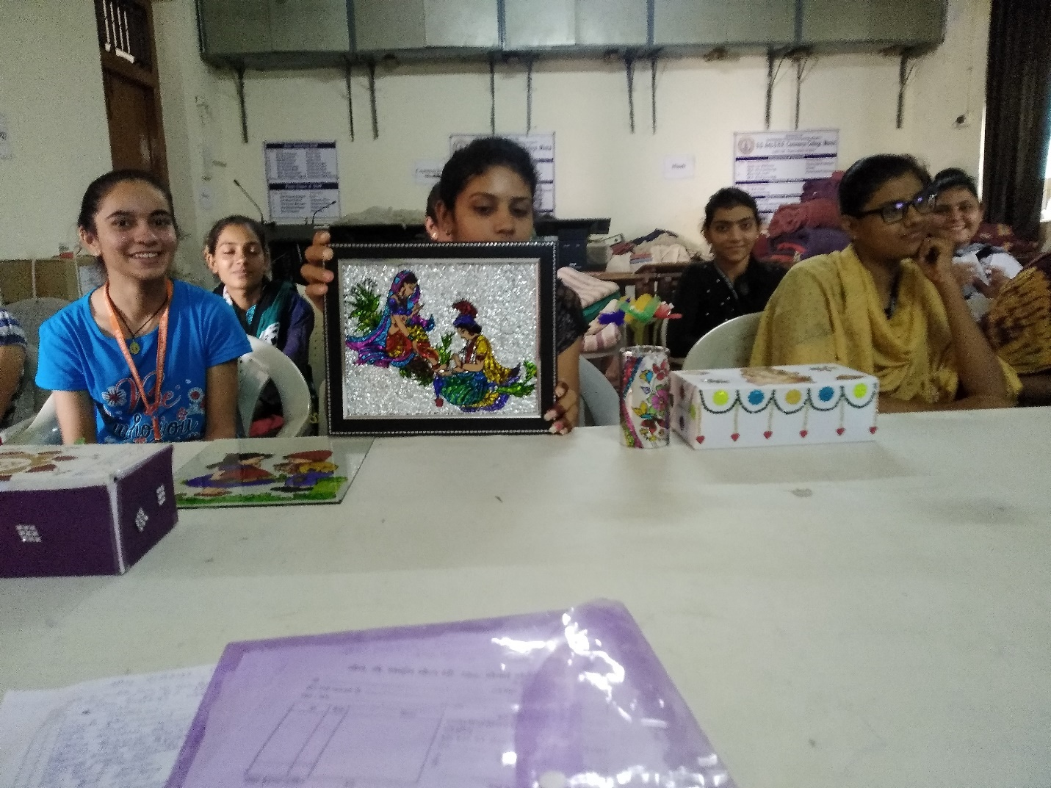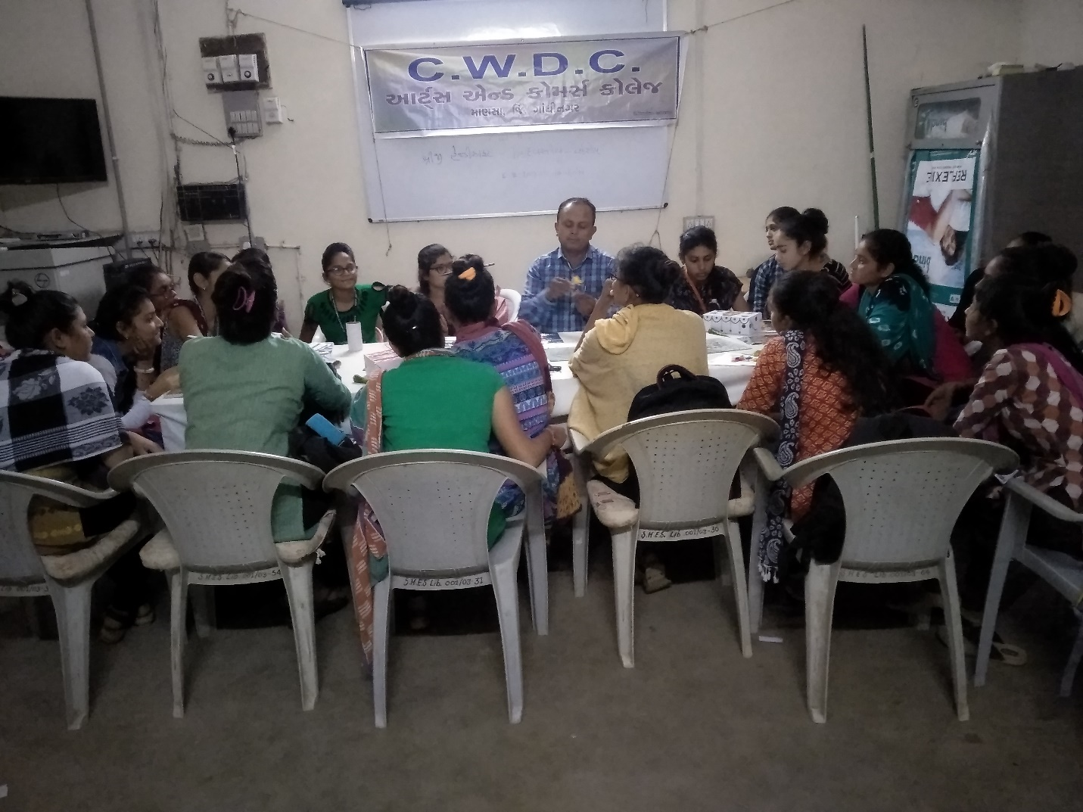

Film show “Beti” 27/8/2019
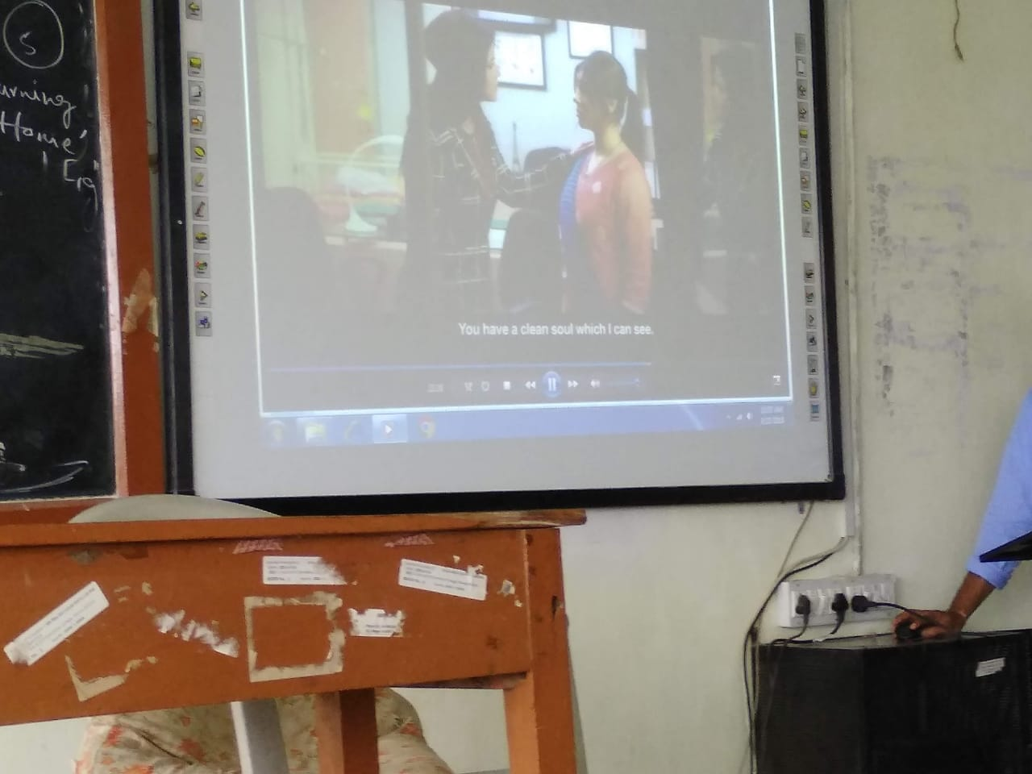
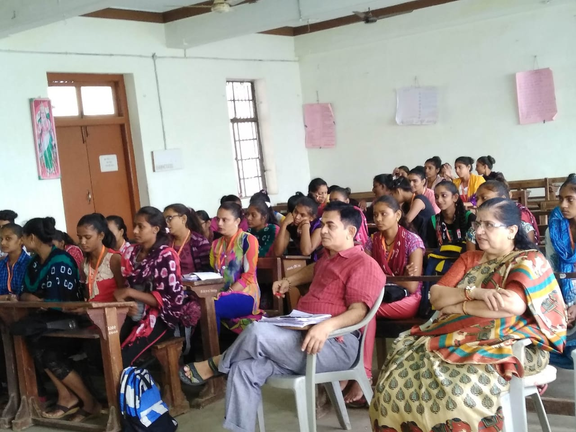
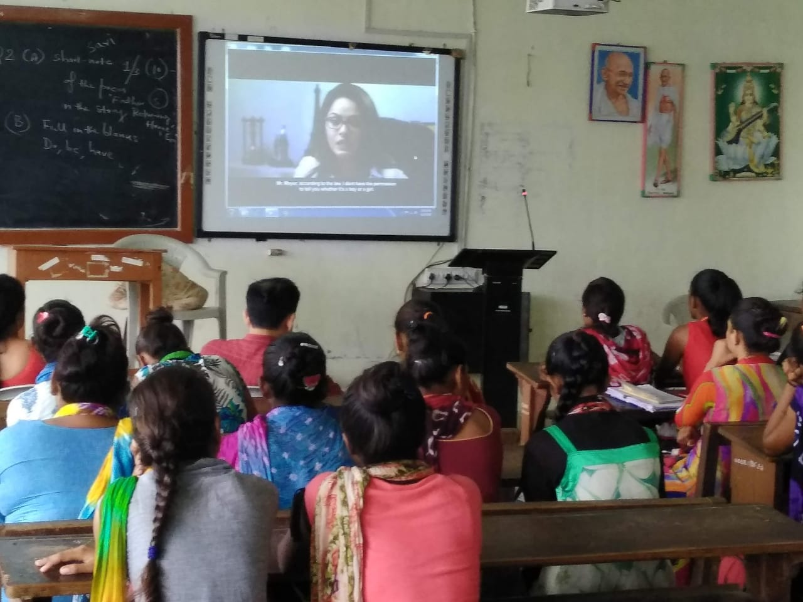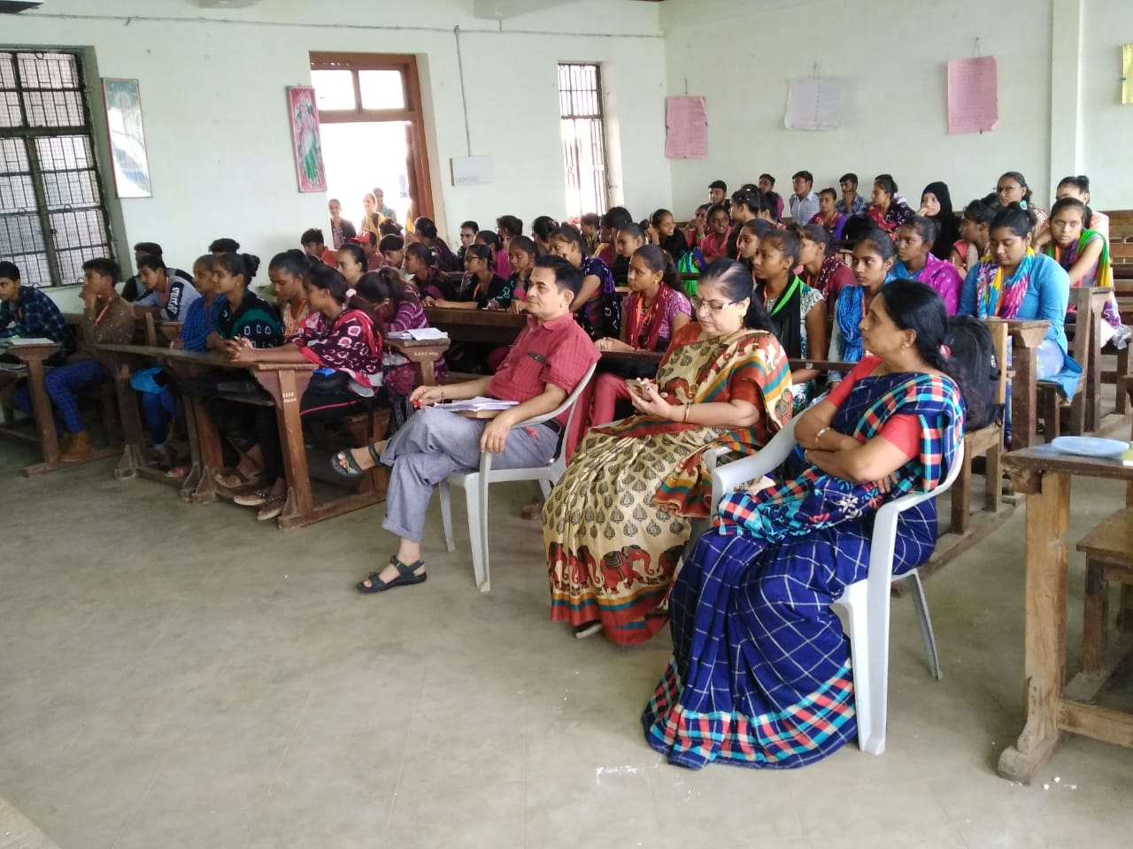
Organized Inter College Competition
Subjects :(1) Poster Making (2) Story Writing (3) Poetry Writing – on
Female Subject (4) Essay Writing
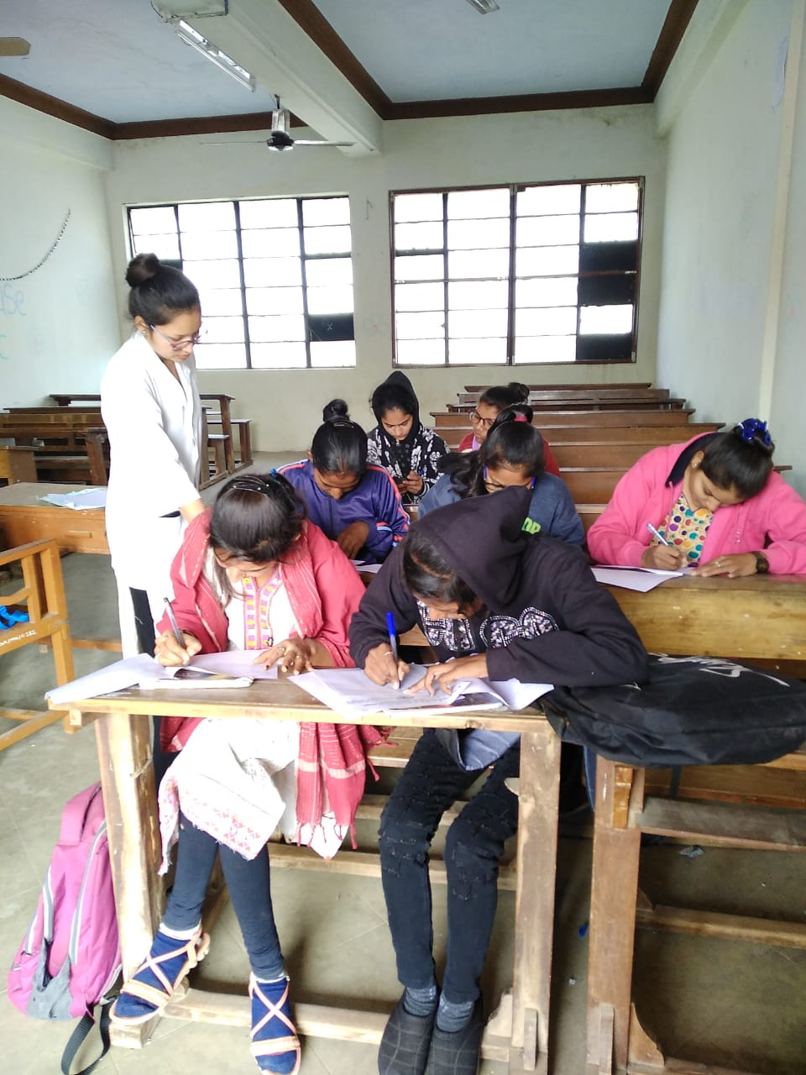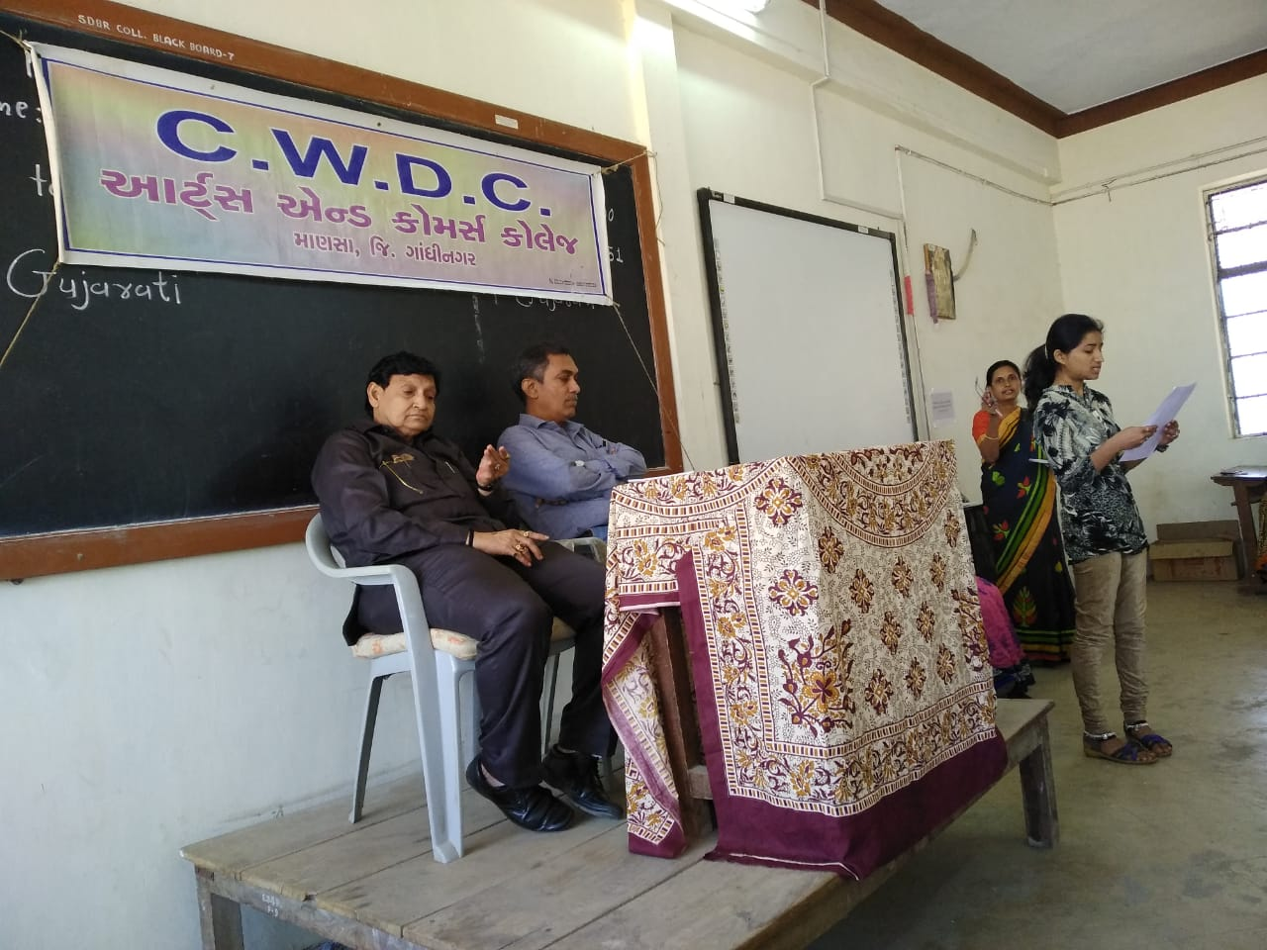
Celebration of “World Women’s Day” 9/3/2020

